**SELENIUM C#-Introduction**

* **Selenium** is an open-source, web [Automation Testing](https://www.guru99.com/automation-testing.html) tool that supports multiple browsers and multiple operating systems.
* **C#** is an object-oriented programming language derived from C++ and Java. C# allows developers to build applications using Visual Studio on .Net platform.

**PACKAGE USED:**

* Selenium.Chrome.WebDriver
* Selenium.Firefox.WebDriver
* Selenium.WebDriver

**PROJECT OVERVIEW:**

In this project, we used selenium C# to scrap the minimum price, maximum price, average kilometer of the car's data from the OLX website.

1. The program runs by double-clicking the EXE file.
2. The car name and year details collected from the user dynamically:

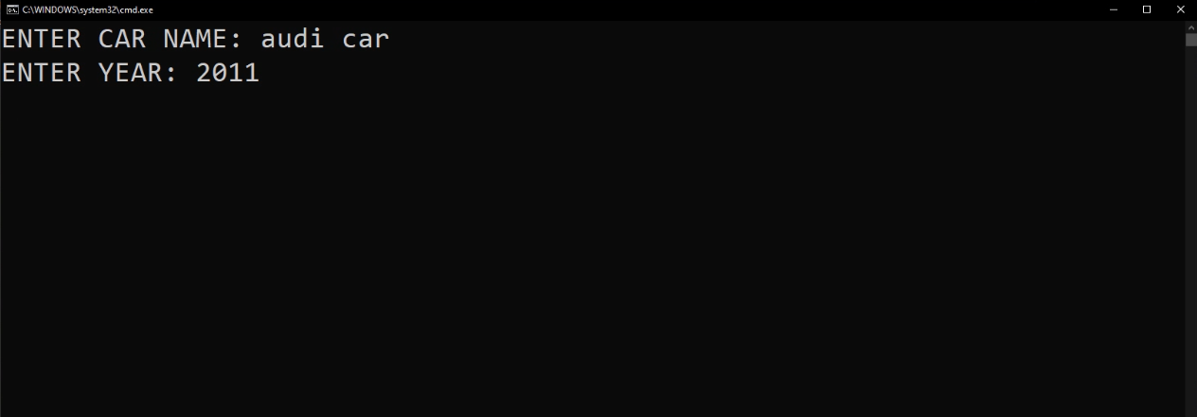

1. After the car name collected from the user, the bot scrap the details about the given car details like titles, prices, year, and kilometers has driven from the website and print them in the console.

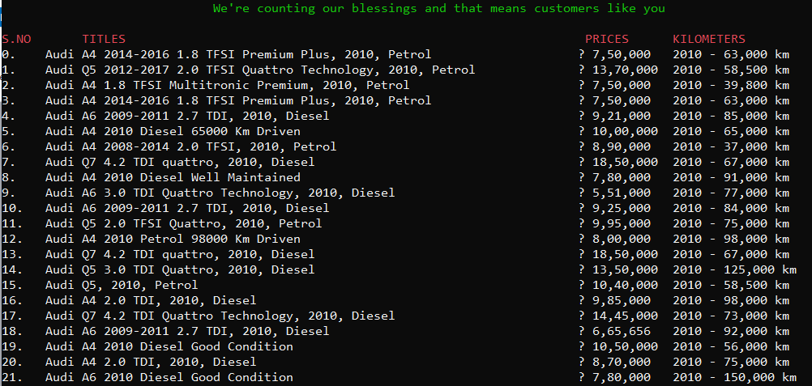

1. the minimum price, maximum price, and total average kilometers are printed at the end of the console.

